Earthquake Prediction and Notification System

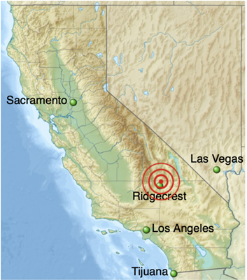

Conceptual Design Review Supplement

SE5101 | Group 2| 20SEP2019

Gabrielle Davenport, Stephen Jason, Ryan Patton, Mike Thiemet

1. Scope

The following content covers Group 2’s Conceptual Design Review previewed on September 20th, 2019. The system under review is a Seismic Prediction Prototype System. The members presenting are Gabrielle Davenport, Ryan Patton, Michael Thiemet, and Stephen Jason.

1. Relevant Documentation
   1. Statement of Need. SE5101 Team 2 Customer (2019, September 19)
2. System Definition

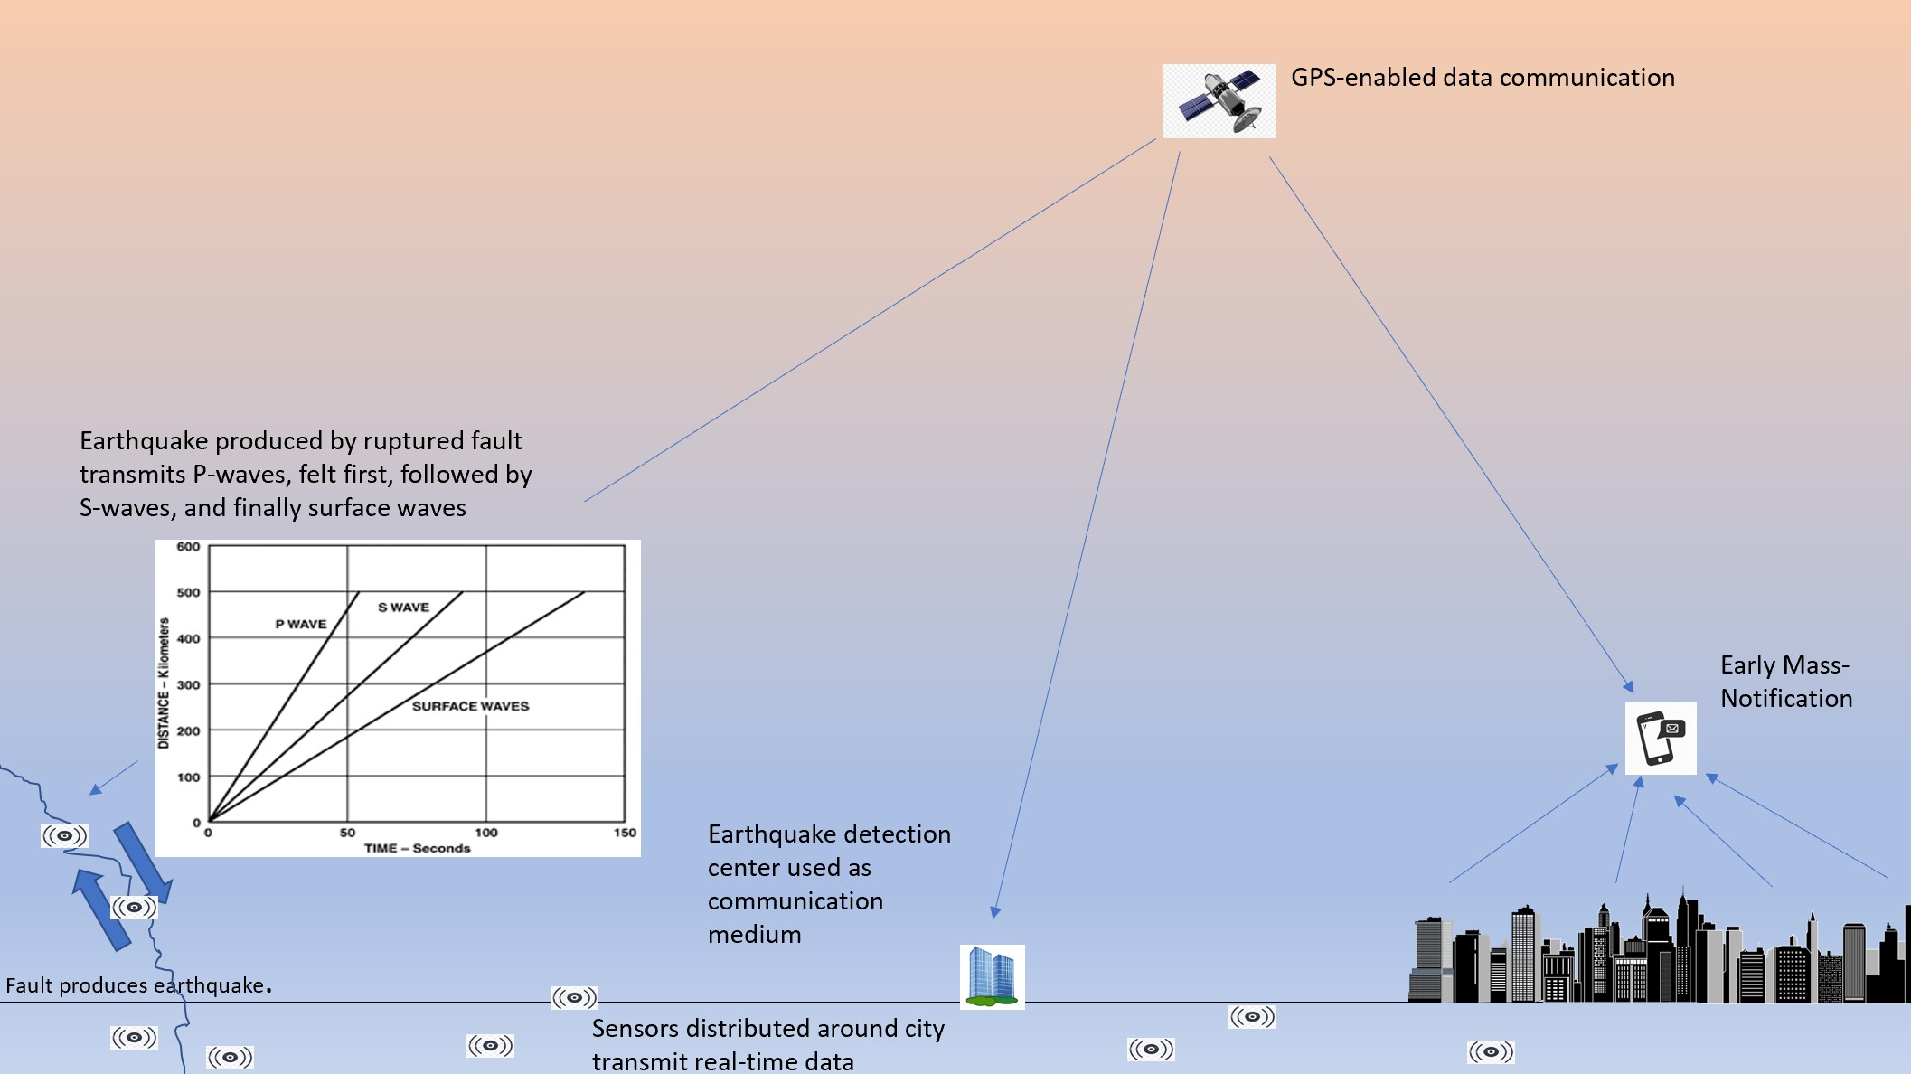

*Figure 1 - Operational Overview of System*

* 1. The Earthquake Prediction and Notification System (EPNS) is a centralized hub to be used by geologists, seismologists, and government officials in order to detect and measure seismic activity. This data will be used to predict future earthquakes within enough time frame to notify affected populations, such that proactive actions can be taken.
  2. Customer Statement of Need:

*There is a need to determine when and where on Earth stress between tectonic plates is building, as it can serve as a potentially good indicator for the possibility of damaging earthquakes in surrounding areas. The system will be able to take into account the various data inputs in order to effectively predict earthquake location and impact such that proper disaster provisions can be put into motion. We expect the system to be able to predict the likelihood of earthquakes (to a certain tolerance level*) up to 2 weeks in advance, allowing the affected government agencies to notify their populations of the upcoming natural disaster, so that precautions can be made. The intended use of the system is to be used by various government agencies/citizens across North and South America. In 2016, the reported costs of natural disasters in the Americas exceeded $50 billion dollars* US. The information provided by the seismic prediction prototype system will give the affected areas’ citizens sufficient notice of critical information (location, strength, timeline, and impact to crucial functions) such that the proper actions are taken. The ultimate goal of our system is the protection of assets and preservation of human lives. The estimated costs of the system will be covered by the affected nation’s government organizations, depending on what the country deems necessary. A magnitude 5.5 earthquake or greater had an average cost of $12 million and a median cost of $484 million from 1985-2015 adjusted for inflation, indicating a need for similar magnitude earthquakes to be detected and proper notification information distributed. When given enough time, proper precautions could be taken to protect against structural and property damage thus saving money. The prototype design must be completed for Chuck White, Project Manager for CSEP, by December 6th 2019, with a prototype delivered within 36 months of project initiation.*

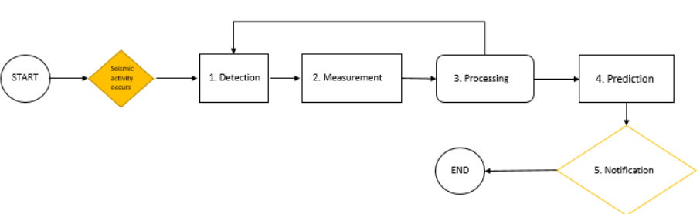

*Figure 2: System Level Functional Flow Diagram*

1. Stakeholder Requirements
   1. The system shall provide accurate information
   2. The system shall handle requests by large populations of people
   3. The system shall utilize data provided by inputs for analysis and prediction.
   4. The system shall be priced affordably private or public organizations.
   5. The system shall operate under for <large> periods of time without requiring maintenance.
2. System Requirements
   1. The system shall detect seismic waves (P-waves and S-waves) greater than 2.0 in magnitude.
   2. The system shall interface with GPS technology in order to quantify the movements of tectonic plates
   3. The system shall store data provided by data inputs.
   4. The system shall allow stored data to be retrieved and analyzed by computation engines.
   5. The system shall analyze the stored data to predict the next earthquake.
   6. The system shall interface with high-speed internet (networks).
   7. The system shall enable the transfer of data between components
   8. The system shall collect data from the following inputs: seismographs, ground motion sensors, global positioning systems.
   9. The system shall use the prediction algorithm to provide a time and place <within some tolerance or confidence level> of a potential future earthquake.
   10. The system shall use both real-time and historical data as inputs to the prediction algorithm.
   11. The system shall collect data for 24 hours a day, 7 days a week, not considering service events.
   12. The system shall process data 24 hours a day, 7 days a week, not considering service events.
   13. If the system predicts an earthquake of a <certain magnitude>, the system shall send a notification to specified parties.
   14. The total system uptime shall be 24 hours a day, 7 days a week per year, excluding unexpected service events.
   15. The downtime for service events shall require a maximum of <2> hours, unless in the case of a total component failure.
   16. The system shall provide routine functionality in the event of a service for specific component.
3. Sub-system Requirement
   1. Seismic Detection Function
      1. Seismometer
   2. Data Storage/Processing
      1. Memory
      2. Data format
      3. Measurement Systems
   3. Computation Engine
      1. Prediction Algorithm
   4. Notification System
      1. Application-Enabled Smartphone Notifications

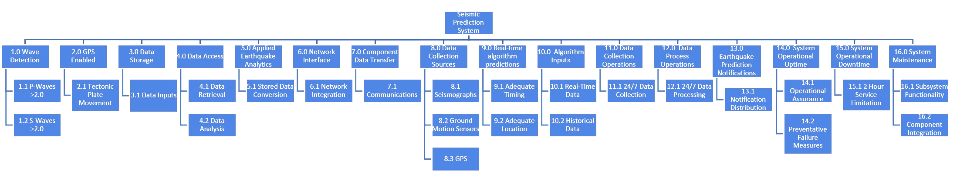

*Figure 3 - Seismic Prediction System Requirements Breakdown*

1. Key Performance Parameters
   1. The system will be able to make a prediction of future seismic activity greater than 2.0 in magnitude within a 2-week time frame, based on the input data provided.
   2. The implementation of the system must use existing technologies in order to limit the cost of system infrastructure (No need for new measurement devices or seismic sensor stations)
   3. The MTBF (Mean-time between failures) for the system in hours, must be greater than 8,760 at the launch of the product.
   4. The system’s prediction algorithm must be able to provide a location of the focus of seismic activity (epicenter) within 25 miles of the actual location.
   5. The system will notify users if it detects seismic activity greater than 2.0 in magnitude. (Social media alert, text message, ringing alarm, etc…)
   6. The system will notify users if it predicts seismic activity greater than 2.0 in magnitude within a 2-week time frame. (Social media alert, text message, ringing alarm, etc…)

*Table 1 - KPP Weighted Table*

|  |  |  |
| --- | --- | --- |
| KPP | Value | Weight (1-5) |
| Prediction Magnitude | >2.0 | 3 |
| Cost | X | 5 |
| Mean Time Between Failure | 8760 hours | 2.5 |
| Notification Time | 2 weeks | 4 |
| Prediction radius | 25 miles | 3 |

1. Alternative System/Subsystem Comparison

Competing Systems Conceptual Overview

Examining the current technologies in place for earthquake detection technologies shows sufficient historical and real-time data currently but a lack of coordination between different systems to relay notifications to large masses of people in a timely manner. The market value of an improved collaboration system would prove invaluable to saving both lives and millions of dollars in infrastructure costs. A number of factors were debated before deciding on the proposed system. Earthquake magnitudes greater than 2.0 start venturing into the territory of physically feeling tremors. Although earthquakes less than 5.0 rarely cause any damage, the technologies in place allow for easy data retrieval of earthquakes on any scale. As long as the transmittal capacity of the system is not compromised by capturing earthquake data from 2.0-5.0, the expansion into this region of magnitude allows for more system verification and improved artificial learning. Secondly, the biggest driving parameter of the system was the cost. The stakes of marginally improved earthquake detection systems is in the millions culminating in a number of possible designs ranging from hundreds of dollars to millions. Referring back and operating on the assumption that sufficient sensor technologies are already in place, the idea for our system returned to improving the timely process flow of information while incorporating outside forms of data. Basing the system on this premise keeps costs low as it’s intended functions deal mostly with network interfacing and software development. Mean Time Between Failure needed a lower prioritization. A one-time inoperable system could yield catastrophic results but the mostly self-sustaining system will not require more than hourly patches. The determination to set a 2 week notification time for the system to masses of people in densely populated areas derives from the core solution to combating earthquakes with improved evacuation times and infrastructure preparation. Finally, the system’s prediction radius should adequately predict the precision and accuracy of incoming earthquakes based on the seismic activity monitors.

The main system design factor revolved around the best method for relaying the message of future damaging earthquakes as early as possible. The increased preparations and evacuations that would happen as a result of the conveyance of this information is outside of the system boundary but is a safe conclusion. Due to non-unified data collections, exclusively regional earthquake tracking systems, extensive relay times between the channels of distribution, erratic, imprecise, and unreliable sensors, lack of implemented artificial learning, and lack of methods to best contact affected parties, our effectively organized system will provide a central hub to equip organizations across North and South America with a tool for timely notifying their respective citizens of earthquake disasters. This conclusion could only be reached after studying various systems and subsystems. At the sub-system level, practical decision-making could only be implemented after deciding on the methods of data communication.

**Alternate Data Communication Options**

Many different information communication methods and sub-systems could be utilized. The hardware and software needed to receive and transmit vast amounts of data with fast upload/download speeds. Factoring into this consideration was the reliability of the hardware and software selected. The hardware is more directly related to budget constraints depending on the amount of computing power needed. The ease, familiarity, flexibility, and universality of C++ make it the perfect software language compliment to any hardware selection. The programmed hardware will communicate with data collecting sources and distribute algorithm outputs to the proper channels in an easy-to-understand format. The methods and channels by which the information will be collected and distributed is expanded on in the following sections. A detailed analysis of the considerations given for communication can be seen in Tables 2 and 3.

*Table 2 - Alternate Information Distribution Methods with KPP’s[1]*

|  |  |  |  |  |  |  |
| --- | --- | --- | --- | --- | --- | --- |
| **KPP** | **KPP Rank** | **KPP Weight** | **Autonomous Source Monitoring** | **Direct Sensor(s) Comms.** | **Direct Fault Line Monitoring** | **Real-Time Monitoring** |
| Costly | 7 | 0.075 | 9 | 5 | 2 | 9 |
| Maintainable | 9 | 0.033 | 8 | 7 | 5 | 8 |
| Reliable | 5 | 0.10 | 7 | 8 | 9 | 5 |
| Proprietable | 3 | 0.15 | 9 | 4 | 8 | 9 |
| Future Growth Capable | 2 | 0.20 | 9 | 5 | 6 | 5 |
| Precisionable | 10 | 0.033 | 6 | 6 | 8 | 4 |
| Operable | 8 | 0.033 | 7 | 6 | 3 | 7 |
| Profitable | 1 | 0.20 | 9 | 4 | 4 | 6 |
| Versatile | 6 | 0.075 | 8 | 6 | 2 | 6 |
| Universal | 4 | 0.10 | 9 | 7 | 3 | 9 |
| **Totals** |  | 1.00 | **8.5** | 5.4 | 5.3 | 6.7 |

*Table 3 - Alternate Information Distribution Methods Feasibility Comparisons*

|  |  |  |  |  |
| --- | --- | --- | --- | --- |
| **Criteria** | **Autonomous Source Monitoring** | **Direct Sensor(s) Comms.** | **Direct Fault Line Monitoring** | **Real-Time Monitoring** |
| Data transmittal technology is mature | 8 | 9 | 9 | 8 |
| Data transmittal technology directly correlates to earthquake predictions | 9 | 9 | 9 | 9 |

**Autonomous Source Monitoring**

Autonomous source monitoring allows for both real-time data collection and improved performance over time as it can learn from past data. The concept is extracting public data from many sources of information pertaining to earthquake monitoring and applying that data to a computational algorithm designed to earlier predict the chances of a catastrophic earthquake striking. The accuracy of the system improves over time as artificial learning techniques are applied and the system already has immediate value and a solid foundation to start from based off of the numerous sources of past earthquake data. The cost of the proprietary technologies are low due to its inherent value coming from the software designed to find variable comparisons where they may not be intuitive. As long as data is collected across each fault and shared, the program could apply that data to any fault and would not be limited to certain regions like other technologies. Once the program is up-and-running, its potential future growth is high because of the amount of publicly available data able to be inputted allowing for improved variable causations and chance happenings over time.

**Direct Sensor(s) Communications**

Direct sensor(s) communications is a method of gathering earthquake data by networking a potential system directly to the sensors surrounding fault line areas of interest. The main benefit of connecting directly to pre-existing or new sensors is the ability to interact with the sources of data directly giving a sense of added credibility to the data. The relative uncostliness of adding a system’s own sensors increases the system’s worth because a wider net is cast for a proprietary domain. The technology on a surface level is practical but the ease with which the system could be duplicated is high. The number of available sensors around faults and one-dimensionality of the measurement method place burdensome limits on growth and development.

**Direct Fault Line Monitoring**

Direct fault line monitoring aims to maximize the number of ways to gather data by direct observation along fault lines. Instead of just collecting data from sensors, the fault lines can be tracked over time to monitor changes in their behavior. To properly observe the seismic activity along faults where impacts would affect citizens and infrastructure, the costliness would be absurdly high. Some points along faults are more susceptible to earthquakes than others leading to the possibility of only covering some critical areas along the faults for observance but the more areas losing focus, the more unreliable the system. Using the Global Positioning System (GPS), fault lines may be tracked but the data correlating precision and accuracy of tracking strictly behavior to the likelihood of an earthquake occurring is still in research and development.

**Real-Time Monitoring**

Real-time monitoring originates from the same idea as an autonomous source monitoring system but without the historical data for added convenience. A simplistic autonomous source monitoring system offers benefits such as slightly reduced cost and accurate monitoring but fails to significantly improve over existing technologies. With the primary goal of early detection as possible, real-time monitoring does little systems in place can already do. The innovation required for substantial profitability and future growth is limited by its ability to produce a better system over time, even if big data can be inputted and outputted in a sensible manner effectively.

Competing Subsystems Conceptual Overview

**Alternate Notification Options**

Many platforms could be used to communicate the collected data to affected organizations and people; television, application-enabled phone notifications, wide-reaching Internet domains, text message alerts, and social media. The KPPs to compare the methods at the system’s component level for notifications are as follows:

* 1. Cost: A measure of the cost of the component throughout its lifecycle as part of a system developed as a marketable product.
  2. Reachability: A measure of the amount of market participants and organizations capable of receiving the earthquake notification with ample time.
  3. Timable: A measure of how quickly the earthquake notification reaches members capable of receiving the communicated message.

*Table 4 - Alternate Notification Options with KPPs[2]*

|  |  |  |  |  |  |  |
| --- | --- | --- | --- | --- | --- | --- |
| **KPP / Alternative** | **KPP Weight** | **Television** | **App Notifications** | **Internet Domains** | **Text Messages** | **Social Media** |
| Cost | 0.15 | 6 | 9 | 5 | 7 | 9 |
| Reachability | 0.35 | 4 | 8 | 6 | 8 | 7 |
| Timable | 0.50 | 4 | 9 | 6 | 9 | 6 |
| **Totals** | 1.00 | 4.3 | 8.7 | 5.9 | 8.4 | 7.5 |

Application-enabled phone notifications is the best platform for communicating an impending earthquake. Text messages and social media -- both aspects of smartphones too -- had similarly high KPP weighted totals. However, creating a system that could send messages to millions of phones in a short time frame would be costly. Furthermore, it may not reach people away from their phones. Although billions of people worldwide across all socio-economic groups have social media accounts, social media accounts are not always checked in a timely manner. A key requirement of the system is its ability to communicate quickly with its intended audience.

**Alternate Seismic Detection Options**

With all of the seismic detection options available in different locations, the best approach to detecting damaging earthquakes early on is to utilize as many resources as possible to gain a better cumulative understanding and approach. All different kinds of seismographs and sensors are readily available to perform their standard functions. The precision of standard instruments credibly measure tremors but fail to correlate early enough how small tremors may build up to severe tremors. Early improved interpretation of seismographs, sensors, and other measurement forms whether through better placement near faults, better cross-analysis between measurement devices, etc… will result in earlier accurate findings and open up earlier communications with affected parties.

The sub-system options for seismic detectors will be analyzed on each of the following technologies:

* Sensors - strategically placed to monitor tremors near fault lines and interpret the tremors numerically
* Algorithm Estimators - computational/mathematical attempts to predict when earthquakes will strike next
* Seismographs - measures ground motion in combination with a recording device and timing device
* Correlation of distantly related variables - assess possible leads of variables to improve computational/mathematical analysis not intuitively understood to affect earthquakes such as climate near faults, weather, etc…
* Combined analytics - a systems-level computational approach to find better relationships between the different detections methods in place

From the listed sub-system alternatives, the following component-level KPPs help to categorize each:

1. Cost: A measure of the life-cycle cost of the component(s) needed to support the seismic predictor system.
2. Accuracy: A measure of how close to the actual magnitude the component gets
3. Operable: A measure of the time and effort needed to run and maintain the component
4. Speed: A measure of the rate the data may be uploaded to the system versus the rate of distribution of the pertinent information after computational analysis
5. Growth: A measure of the potential of the system to improve its marketability and profits

*Table 4 - Alternate Seismic Detection Options with KPPs[3]*

|  |  |  |  |  |  |  |
| --- | --- | --- | --- | --- | --- | --- |
| **KPP / Alternative** | **KPP Weight** | **Sensors** | **Algorithm Estimators** | **Seismographs** | **Related Variables** | **Combined Analytics** |
| Cost | 0.125 | 2 | 7 | 5 | 9 | 7 |
| Accuracy | 0.20 | 8 | 3 | 8 | 2 | 9 |
| Operable | 0.125 | 8 | 5 | 8 | 4 | 7 |
| Speed | 0.30 | 4 | 8 | 4 | 8 | 8 |
| Growth | 0.25 | 6 | 9 | 5 | 7 | 9 |
| **Totals** |  | 5.6 | 6.8 | 5.7 | 6.2 | 8.2 |

A combined analytics approach is the preferred seismic detection method. Using a “best of both worlds” approach, the system will input many different readings and sources of information, tying them together in a way best suited for early detection.

**Additional Alternate Options**

The following subsystems require further trade studies and discussion to decide what the best approaches will be for their system integration:

1. Data Storage/Processing: Additional studies will determine the best ways to analyze and process vast amounts of data input into a logical format.
2. Computation Engine: Additional studies will determine computational specifications and needed pseudo-algorithms to make early best predictions from the data.

After all subsystem decisions are made, a systems-level approach will guide the realization of integration between the subsystems.

1. Feasibility Schedule
   1. 6 months for research/design/development
      1. Trade Studies
      2. KPP Comparisons
      3. Work Breakdown Structure
      4. Mission Concept of Operations
   2. 2 months for prototype
      1. Computer-aided Design
      2. Engineering Drawings
      3. System Schematics
      4. Integration Plan
   3. 4 months for production
      1. Order Parts
      2. Manufacturing
      3. Assembly
      4. Integration Troubleshooting
      5. Software Development
   4. 4 months for test
      1. Test Readiness Review
      2. Test Suitability Requests
      3. System-Test Assurance
      4. Test Validation
      5. Test Verification
   5. 3 months for deployment
      1. Environmental Conditions Assessment
      2. Troubleshooting
      3. Gather Real-Time Data
   6. We predict a useful system lifecycle of 5 years
      1. Assumes multiple refinement periods
      2. Accounts for unscheduled hardware and software maintenance periods
      3. Improved credibility from realized earthquakes while deployed
2. Conclusion

The idealized seismic prediction system still needs further analysis and development to complete its design. The design decisions made so far define key system attributes that will help define the remainder of its design derived from its requirements. With further refinement and system definition, the system’s design will drastically improve the short amount of time for evacuation and preparation from a cataclysmic earthquake.

1. Evaluation Key Scale 1-10: 10 = most effective, 1 = least effective
2. Same Evaluation Key Scale used as in Table 2
3. Same Evaluation Key Scale used as in Table 2